SYLLABUS FOR CSC 115
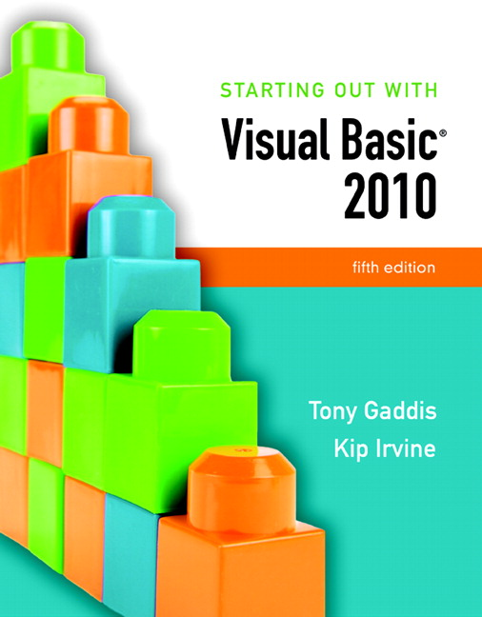
COURSE DESCRIPTION: An introductory course in computer science using Visual Basic.NET. Topics include designing, creating and debugging interactive, event-driven programs with a graphical user interface and developing problem-solving skills and techniques of computer programming.

COURSE OBJECTIVES: Upon successful completion of this course, the student should be able to:
- Master the use of the syntax, structure and constructs of the Visual BASIC language.
- Analyze problems typical of the business, scientific or home environment and to formulate solutions in quantitative terms capable of computer solution.
- Design algorithms typically used in computer programming.
- Master the techniques of designing, coding, entering, correcting and executing a Visual BASIC program.

PREREQUISITE: MATH 090, with a grade of 2.0 or higher, or instructor’s permission.

MEETINGS: Mon/Wed: 6:00 – 8:30pm ALD101.

CONTACT:
E-Mail is preferred
Campus Phone: 425-640-1339 X7053
E-Mail: alvin.kroon@edcc.edu.

REQUIRED TEXTBOOK: Starting Out With Visual Basic 2010, 5th Edition by Tony Gaddis and Kip Irvine, 5th edition (Pearson, 2010, ISBN: 0-13-611340-0).
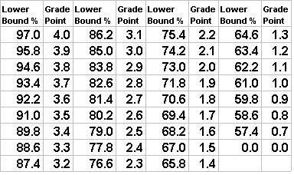
GRADING RULES:
- Two Exams. 50%
- Two Projects. 40%
- Attendance 10%
- Grades - see to the right.
- No incompletes will be given unless there are EXTRAORDINARY circumstances.
- There are no make-up exams or quizzes, unless you provide prior notification and verifiable, written evidence for serious medical emergency.
- Extra credit problems may be assigned (these are optional).
- As instructor, I reserve the right to change any of the above rules at any time (however, I most probably won't).

EXAMS/PROJECTS/HMW/LABS:
- There are two exams: a mid-term and a final. Each counts for 25% of your grade and no makeup is offered for either one. They consist of 50 multiple-choice questions, must be taken in class on specific dates (see syllabus) and are timed. Please make sure no mishaps happened during the taking of the exams.
- Labs #1 and #2 are required to be submitted as zipped files via the Digital Drop Box before the due date. None of the other labs, except Lab #1 and Lab #2, need to be submitted as they are not graded. However, you are strongly encouraged to complete them, as they are often your “life-line” to the projects.
- You are not required to submit the homework assignments, but you do not stand a chance in passing this course unless you do them regularly and completely. Each homework contains a link to a site that you are encouraged to visit and explore. You should comment on its layout, ease of use, content, etc., in Blackboard’s Discussion forum. Very often these sites are valuable resources and you should use them to supplement your text and lessons.
- There are two or three programming projects to be completed individually—all count for 40% of your grade.
- These projects MUST represent your own work. Although you may get help from the Learning Support Center, do not submit any code written by someone else. Your code must demonstrate your knowledge and you will be asked to explain any "advanced" code submitted in your work.
- They must be zipped and submitted electronically via the Digital Drop Box before due date (Student Tools/Digital Drop Box/Send File). Please make sure that you SEND and NOT ADD the zipped file that contains the entire project with all files and folders. Alternatively, you can bring the project to class on the due date saved on appropriate medium (diskette, usb flash pen, CD,…). Please make sure your zipped file contains all of the projects’ files and that it has been scanned for viruses.
- The projects should be identified with at least your name, class and project number or name, and it should contain all pertinent files in appropriate folders.
- Turning a project one day late will cost you 20% of the project’s points; two days late costs 30%. Projects late for more than two days are not accepted. A project is late if it is not submitted by midnight of the due date.

REQUIRED MATERIALS: For this course you will need the following products and competencies:
- A relatively fast PC with vast memory and a large hard drive (I recommend a Pentium 4, 1.8GHz or faster with at least 512MB RAM memory, and at least 80G hard drive).
- Microsoft Windows XP (Home or Professional), Microsoft Windows Vista or Microsoft Windows 2000 (Professional or Server) with the latest updates (SP4 for Windows 2000 at the time of this writing), or Microsoft Windows 2003.
- A Web browser - Netscape Navigator, Avant Browser, Opera, Mozilla Firefox or Internet Explorer - version 6.0 or higher. Blackboard seems to work best with Firefox.
- An email account and the knowledge of how to send and receive email with attachments.
- The ability to connect uninterruptedly to the Internet, to navigate the Web (use a browser), and handle multiple open windows.
- The ability to zip, unzip, open, close, and save files (WinZip or some other packing/unpacking utility—for example UltimateZip).
- Familiarity with the Blackboard 8 system (see http://support.blackboard.com/).
- MS Office, and Adobe Reader.
- Student resources for the text are found at http://www.pearsonhighered.com/gaddisvb/
- Visual Basic.NET 2010. Your textbook should contain Visual Basic 2010 Express CD or DVD, a free lightweight VB.NET edition that will suffice for this class. You need to install this software but make sure you read the Before You Begin section in your text before you do so. Alternately you can download Visual Basic 2010 Express from the Microsoft site http://www.microsoft.com/express/.
- You may contact Misty Cline (mcline@email.edcc.edu) in the Computer Science Department to obtain a free download of Microsoft Visual Studio 2010, Windows 7, and Microsoft Visio
- Toll-free technical support (24/7 service) for BlackBoard is located at http://blackboard.edcc.edu. (Click on the HELP button located on the top of the page).
- Successful completion of student responsibilities in this class requires access to BlackBoard via an Internet browser. You are expected to login to the BlackBoard classroom at least 5 times per week. Instructions for access to BlackBoard may be located online at the following address: http://online.edcc.edu/study/Bb_login.html.

RECOMMENDATIONS:
  - Check for announcements and assignments on daily basis. Attendance is not part of this course—but do practice daily visits to your Blackboard site. Allocate at least two hours per day for work on assignments.
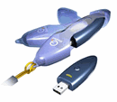
  - Keep a record and copies (on your hard drive or zip disk or USB Flash Disk) of your labs, projects, notes and homework assignments—you are not required to submit the homework assignments, but their completion is imperative for success in this class.
  - Read the text, the lessons, articles, homework links, and any other valuable sources.
  - Logon to the text book site and register for the Companion Website. You will find the access code in the front of your textbook. This is an extremly valuable resource for this class. The Video Notes, Self-Assesment Quizzes and Glossary are especially important. (Note: If English is your Second Language, the Video Notes are extremely helpful.)
  - Memorize important identities, definitions, and results.
  - Copy the code examples from your text and create a work folder on your hard drive.
  - Participate avidly and regularly in the Discussion Board—this means that you should post questions and answers (as well as comments) in the appropriate threads of the Discussion Board. Please don’t wait until the end of the quarter to post all of your comments on homework links.
  - Do all the required homework assignments, tutorials, labs and projects on timely fashion.
  - Ask questions and seek help when puzzled.

MISCELLANEOUS RULES:
- It is your responsibility to withdraw before the appropriate deadlines.
- Pay attention to important dates from the Academic Calendar and from the class syllabus.
- Cheating, impersonation, and plagiarism are academically intolerable and a violation of standards of student conduct. The academic honesty policy of ECC will be strictly enforced.
- If you have a medical problems which might interfere with your class, you need to disclose it and the action you need to take if the problem occurs during class, the name and telephone number of your physician and/or names and numbers of people who can be called to take you home or to a place designated for your care.
- If you require an accommodation for a disability, please contact Services for Students with Disabilities, MLT 159, (425) 640-1320, ssdmail@edcc.edu.

STUDENT RESOURCES:
1. Learning Support Center. Meadowdale Hall 260. (425) 640-1750
2. Multicultural Services Center. Mountlake Terrace Hall 122. (425) 640-1538
3. Counseling Center. Mountlake Terrace Hall 123. (425) 640-1358
4. Bookstore. Mountlake Terrace Hall, 1st floor. (425) 640-1672.
5. Campus Safety. Mountlake Terrace Hall 102. (425) 640-1501.
6. Services for Students with Disabilities. Woodway Hall 114. (425) 640-1320.
7. Student Career and Employment Services. North Campus Complex. (425) 640-1445.
8. Women’s Program. Triton Union 132. (425) 640-1309.
9. Student Services on-line at http://www.edcc.edu/stulife.
- Career Action Center at http://careeractioncenter.edcc.edu.

GRADING SUMMARY (Projected: Final points may vary.)

Item | Points | Percent
Homework | 16 | 6.8%
Attendance | 20 | 8.5%
Assingment1 | 5 | 2.1%
Assignment2 | 5 | 2.1%
Project 1 | 30 | 12.7%
MidTerm | 50 | 21.2%
Project 2 | 30 | 12.7%
Project 3 | 30 | 12.7%
Final | 50 | 21.2%
Total | 236 | 100.0%

